**Assignment - 4**

1.)Display your age in months and days

select months\_between(to\_date(sysdate), to\_date('04/03/1997')) as "diff in months", to\_date(sysdate) - to\_date('04/03/1997') as "diff in days" from dual

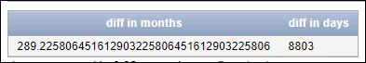

Display Independence day date in Words.(15th August Nineteen Forty Seven)

select to\_char(sysdate,'ddth month year') as "date in words" from dual

*Note: Here we have to change sysdate to what time we need*

C:\Users\user\Pictures\Screenshots\date in words 1.PNG

select to\_char(sysdate,'ddspth month year day') as "date in words" from dual

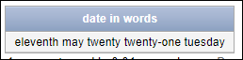

3.)Split the word **"shiva sai shankar"** into first, middle and last names.

select substr('shiva sai shankar', 1, instr('shiva sai shankar', ' ', 1, 1)-1) as "First Name" ,

substr('shiva sai shankar',instr('shiva sai shankar',' ',1,1)+1,instr('shiva sai shankar',' ',1,1)-2 ) as "Middle Name" ,

substr('shiva sai shankar', instr('shiva sai shankar', ' ', 1, 2)+1) as "Last Name" from dual

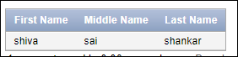

Implement to\_date,to\_char, sysdate, timestamp,add\_months, months\_between, next\_day, currentdate, etc..

select to\_date(sysdate) from dual

C:\Users\user\Pictures\Screenshots\to_date.PNG

select to\_char(hiredate, 'dd mon yyyy') as "date fromat" from emp

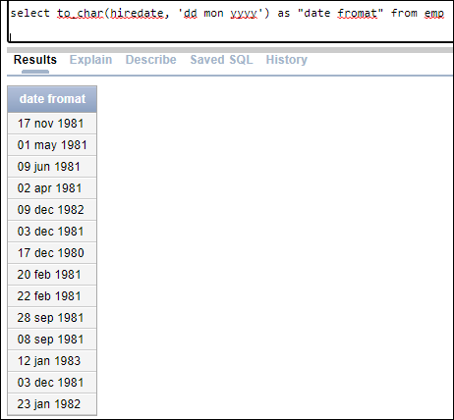

select sysdate from dual

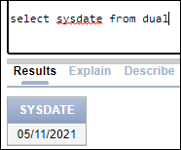

select systimestamp from dual

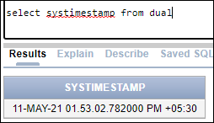

select current\_date from dual

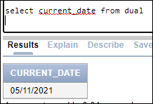

select current\_timestamp from dual

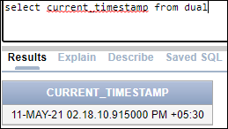

select extract(year from sysdate) as year from dual

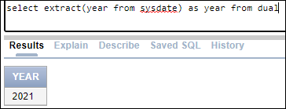

select extract(month from sysdate) month from dual

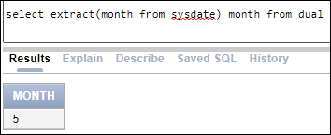

select extract(day from sysdate) as "date" from dual

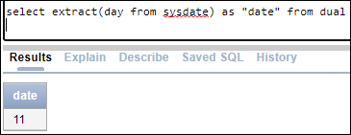

select last\_day(sysdate) from dual

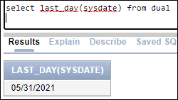

Write a SQL Query which includes all basic keywords and explain with steps for **Order of Execution**

select distinct e.deptno,count(\*) as "dept count" from emp e

inner join dept d on e.deptno = d.deptno

where e.empno > 7369

group by e.deptno

having count(\*) > 3

order by e.deptno

